SAS Graduation Awards Database
https://secure.sas.rutgers.edu/apps/gradawards/
DUE APRIL 15
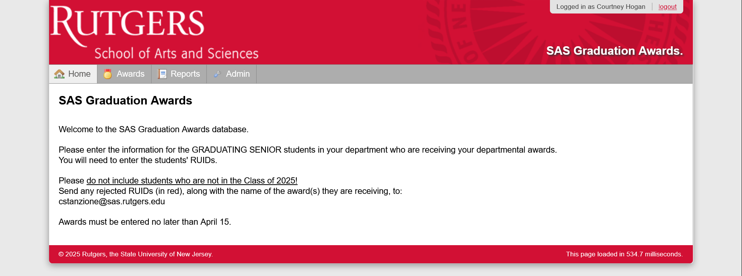
Select the Awards tab:
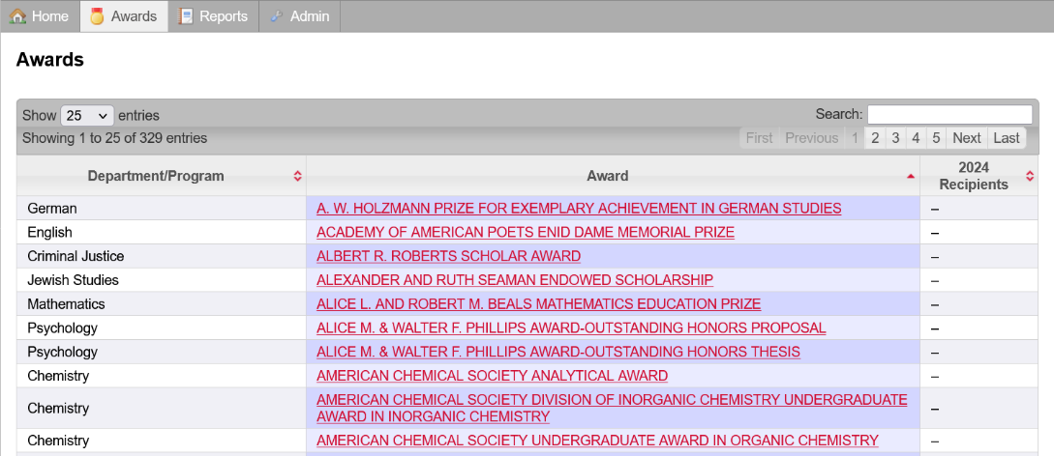
Awards are grouped by department – all awards that were granted within the last 5 years are already in the system. Click on an award to add recipients:
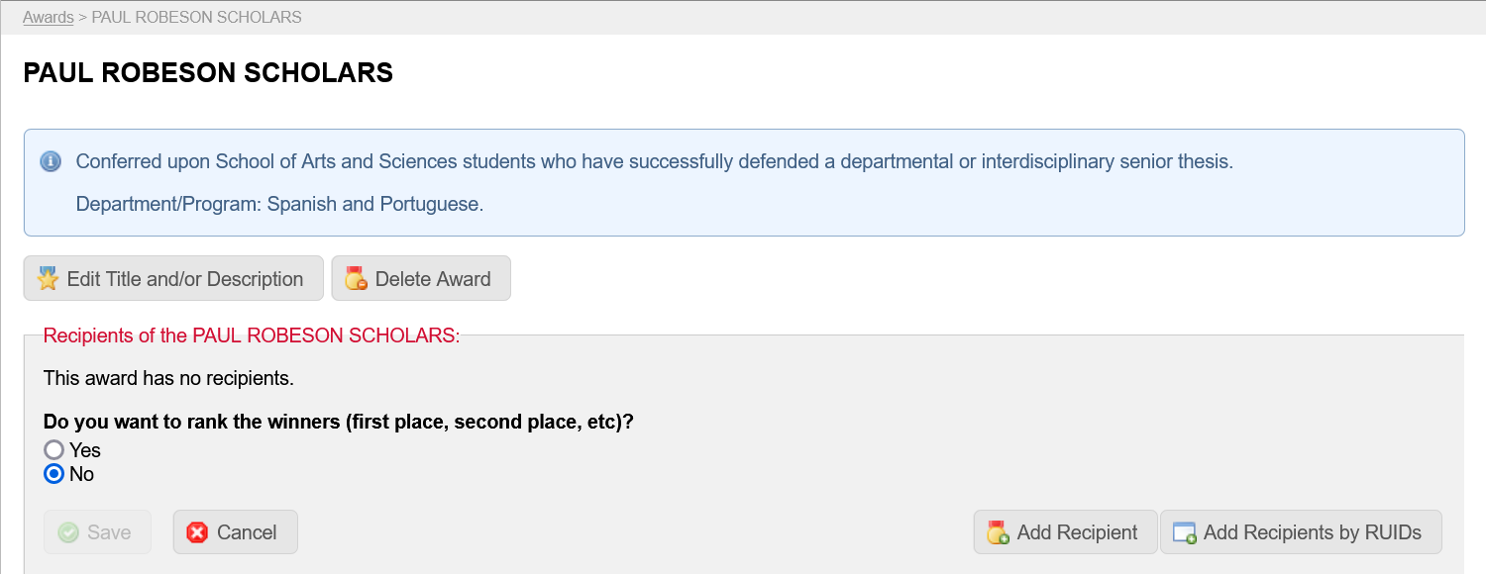

If you just have one recipient, select Add Recipient and you will be prompted to enter the student’s RUID.
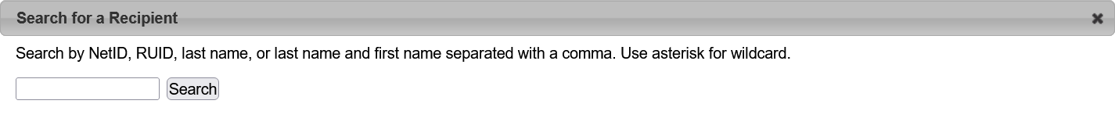
The system will look-up the student and automatically populate the full name. Choose SELECT to save the student to the list of recipients. Repeat this for as many students as you want to add individually.
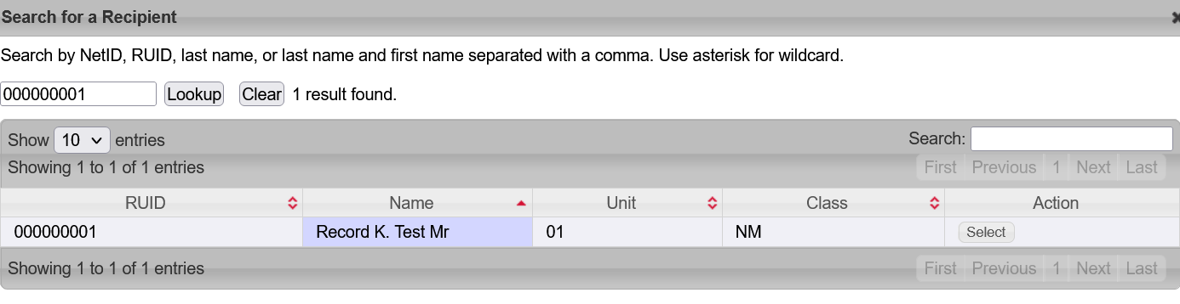

REMEMBER: if you have a list of students all receiving the same award, we now have a batch upload option. Click “Add Recipients by RUID”, then enter RUIDs and click “Add”!
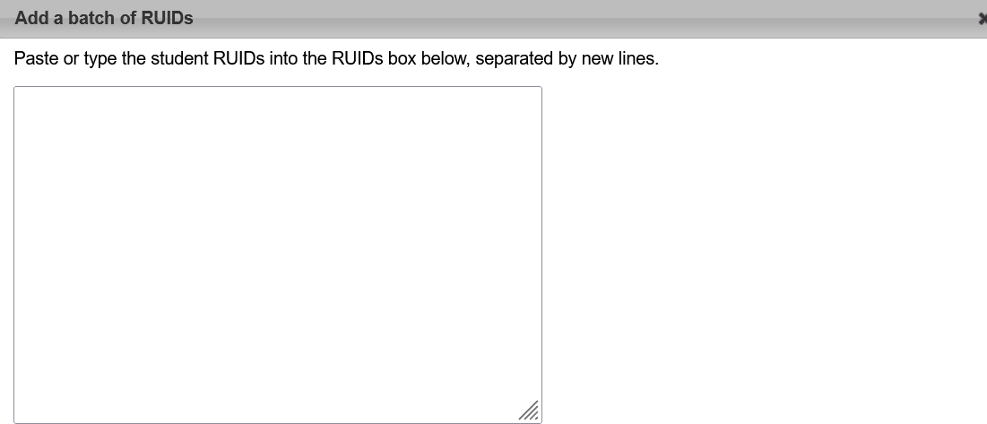
Any RUIDs returned as errors (in red) please email to Courtney (cstanzione@sas.rutgers.edu) for further vetting (most often these are juniors or non-SAS students).

If you have an award that grants ranked recipients (first place, second place, third place, honorary mention), select YES under the question: Do you want to rank the winners (first place, second place, etc)? and you will be able to assign ranks. You can have multiple students with the same rank, and you can skip ranks.
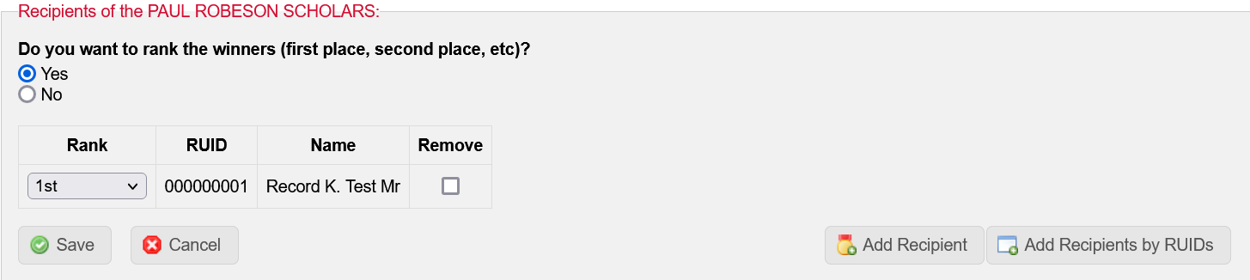
When you’re done assigning recipients to a given award, select SAVE. This will bring you back to the Awards List.
If you have new awards to give out this year, select Add an Award from the Awards tab:
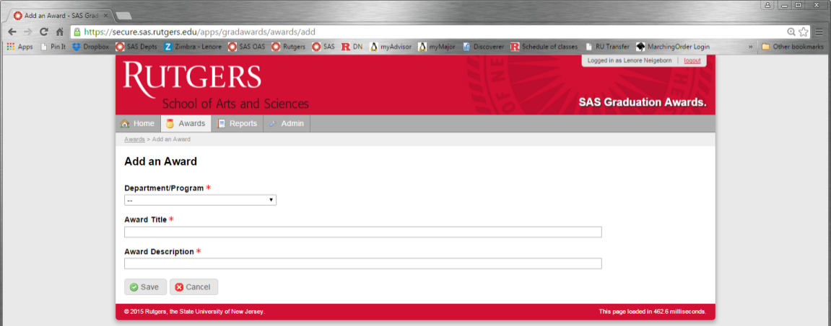

Each new award needs to be assigned to a department or program, which you can select from the Department/Program dropdown menu.
Provide an Award Title and Award Description. This text will be inserted directly into the graduation program, so please check your spelling and grammar!
Award descriptions should all begin with: “Awarded for…”, or “Granted for…”, or “Presented to…” – you get the idea! Please keep descriptions short – ONE sentence – end with a “period.”

If your department isn’t on the dropdown list, contact Courtney Stanzione (cstanzione@sas.rutgers.edu) to update the system.

